Industrial IoT Architecture and Applications
Mid-Course Project

Title:-Position Monitoring System
Date:27-06-2026

Submitted by-

Name: Ragunath K
Reg no: 23BEC1441
Programme: B.Tech – Electronics and Communication Engineering
Institution: Vellore Institute of Technology (VIT), Chennai

AIM:
To develop a real-time position monitoring system using an ESP32, MPU6050 sensor, and OLED display that measures and displays the object's orientation and movement using accelerometer and gyroscope data.

PROBLEM STATEMENT:
Design and implement a system to monitor the position and orientation of an object. Utilize the simulation tool to display real-time accelerometer and gyroscope data on an OLED screen.

SCOPE OF THE SOLUTION:
The proposed Industrial Internet of Things (IIoT) Position Monitoring System is designed to monitor the positi on and orientation of an object in real time using an ESP32 microcontroller, an MPU6050 accelerometer and gyroscope sensor, and an OLED display. The system collects motion data, processes it, and displays the sensor readings continuously through a Wokwi simulation.
The scope of this project includes:
- Monitoring the object's movement and orientation using accelerometer and gyroscope data.
- Displaying real-time sensor readings on an OLED display.
- Simulating the complete system in the Wokwi platform before hardware implementation.
- Providing a simple, low-cost, and reliable solution for motion monitoring.
- Demonstrating the application of Industrial IoT concepts for industrial automation and equipment monitoring.
- Enabling future integration with cloud platforms such as ThingSpeak, Blynk, MQTT, or AWS IoT for remote monitoring and data logging.
- Providing a scalable solution that can be enhanced with GPS, wireless communication, data analytics, and alert systems for advanced industrial applications.
- Continuously monitors the object's position and orientation with minimal delay, enabling real-time observation of motion.
- Supports accurate measurement of acceleration and angular velocity along the X, Y, and Z axes for improved motion analysis.
- Provides an easy-to-understand visual interface through the OLED display for quick interpretation of sensor data.
- Reduces the need for manual inspection by automatically acquiring and displaying motion information.
- Offers a modular design that allows additional sensors and communication modules to be integrated without major hardware modifications.
- Can be used as a learning platform for understanding embedded systems, sensor interfacing, and Industrial IoT technologies.
- Supports future implementation of data storage and historical trend analysis for monitoring equipment performance over time.
- Enables the development of condition-monitoring applications by detecting abnormal movement or orientation changes in industrial equipment.
- Can be integrated with wireless communication technologies such as Wi-Fi or Bluetooth for remote monitoring and control applications.
- Provides a scalable foundation for smart factory applications, including automated monitoring, predictive maintenance, equipment tracking, and Industrial IoT-based decision-making.

REQUIRED COMPONENTS TO DEVELOP SOLUTION:

HARDWARE COMPONENTS:
- ESP32 Development Board
- MPU6050 Accelerometer and Gyroscope Sensor
- SSD1306 OLED Display (128 × 64)

SOFTWARE COMPONENTS:
- Arduino IDE
- Wokwi Simulator
- GitHub
- ESP32 Board Package
- Adafruit MPU6050 Library
- Adafruit Unified Sensor Library
- Adafruit SSD1306 Library
- Adafruit GFX Library

CLOUD ENVIRONMENT:
- ThingSpeak IoT Cloud Platform
- Wi-Fi Connectivity (Wokwi-GUEST Network)

FLOW CHART OF CODE:

START

▼
Initialize ESP32 Board
│
▼
Initialize I2C Communication
│
▼
Initialize OLED Display (SSD1306)
│
▼
Initialize MPU6050 Sensor Module
│
▼
Connect to Wi-Fi Network
│
▼
Initialize ThingSpeak Client
│
▼
Read Accelerometer Data (X,Y,Z)
│
▼
Read Gyroscope Data (X,Y,Z)
│
▼
Process Sensor Readings
│
▼
Display Values on OLED Screen
│
▼
Upload Sensor Data to ThingSpeak Cloud
│
▼
Upload Successful?
┌──────────┴──────────┐
│ │
YES NO
│ │
▼ ▼
Wait 20 Seconds Display Upload Error
│ │
└──────────┬──────────┘
│
▼
Repeat (Continuous Loop)
│
▼
END

SIMULATED CIRCUIT(WOKWI):

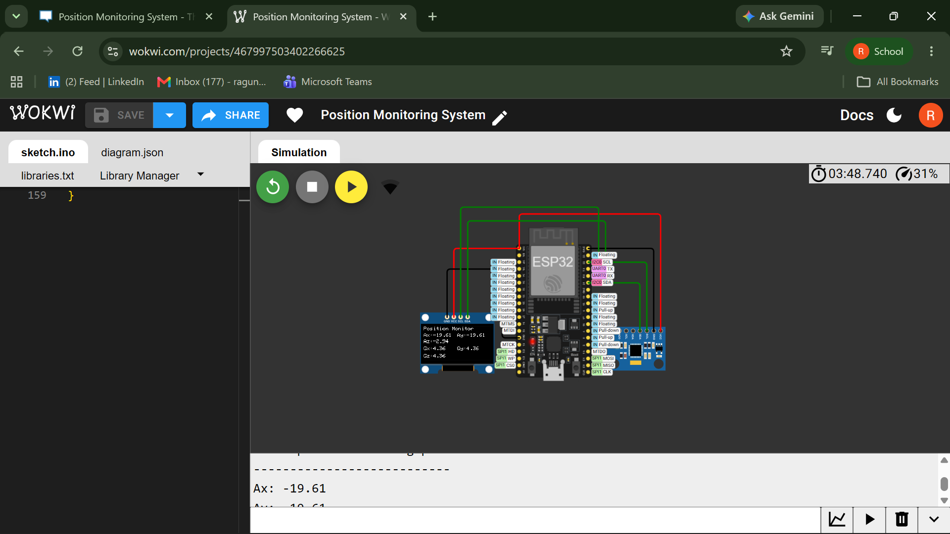

OUTPUTS:

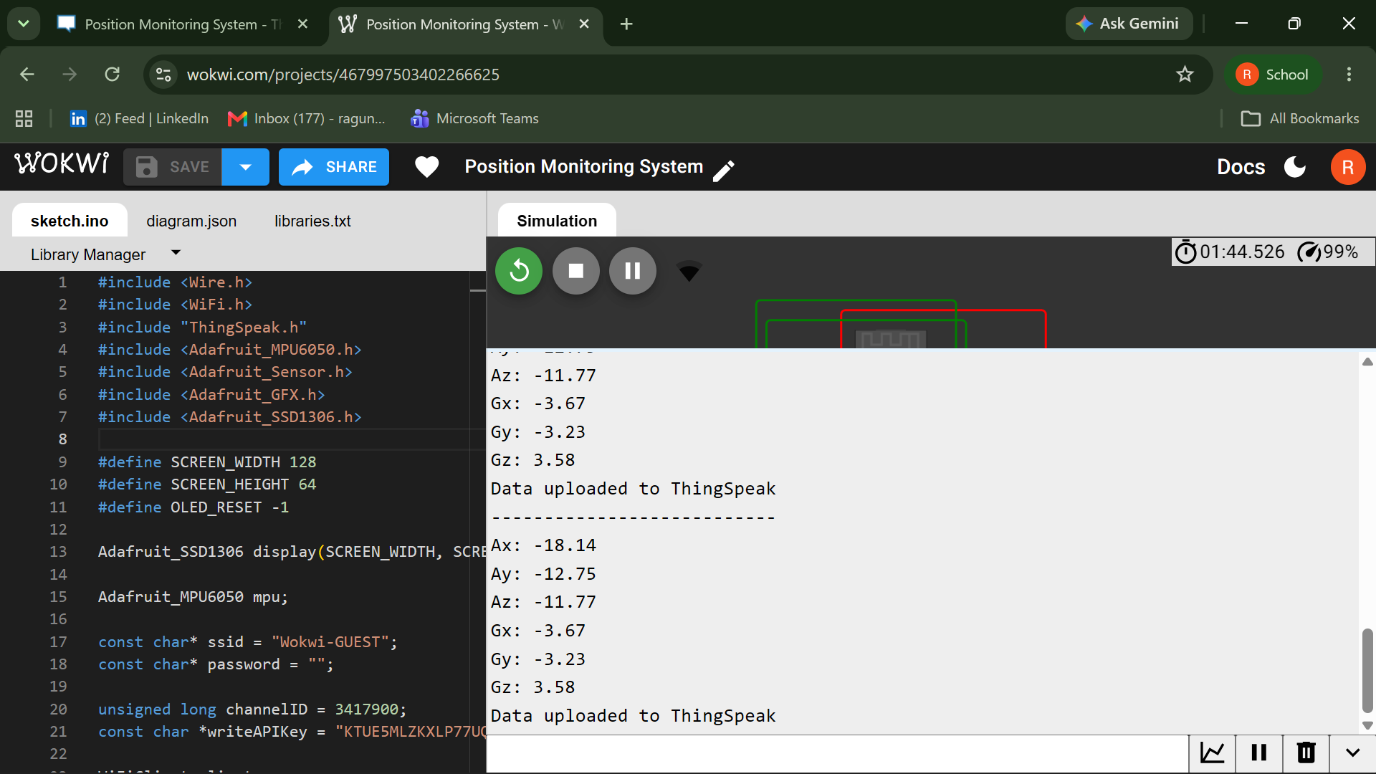

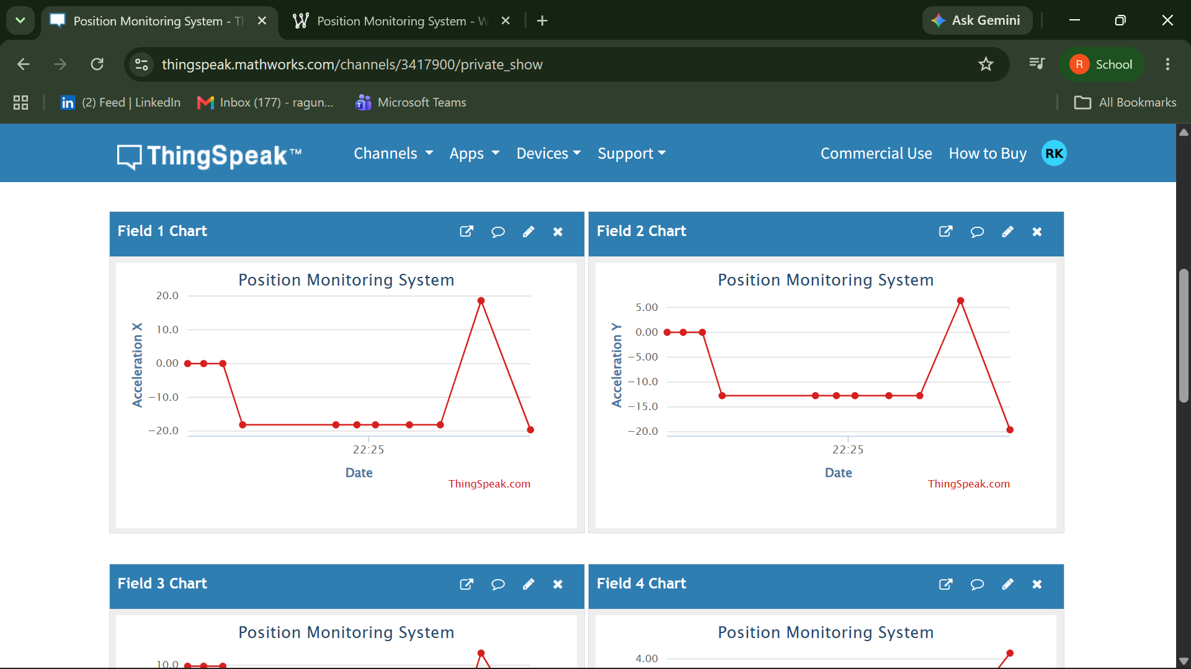

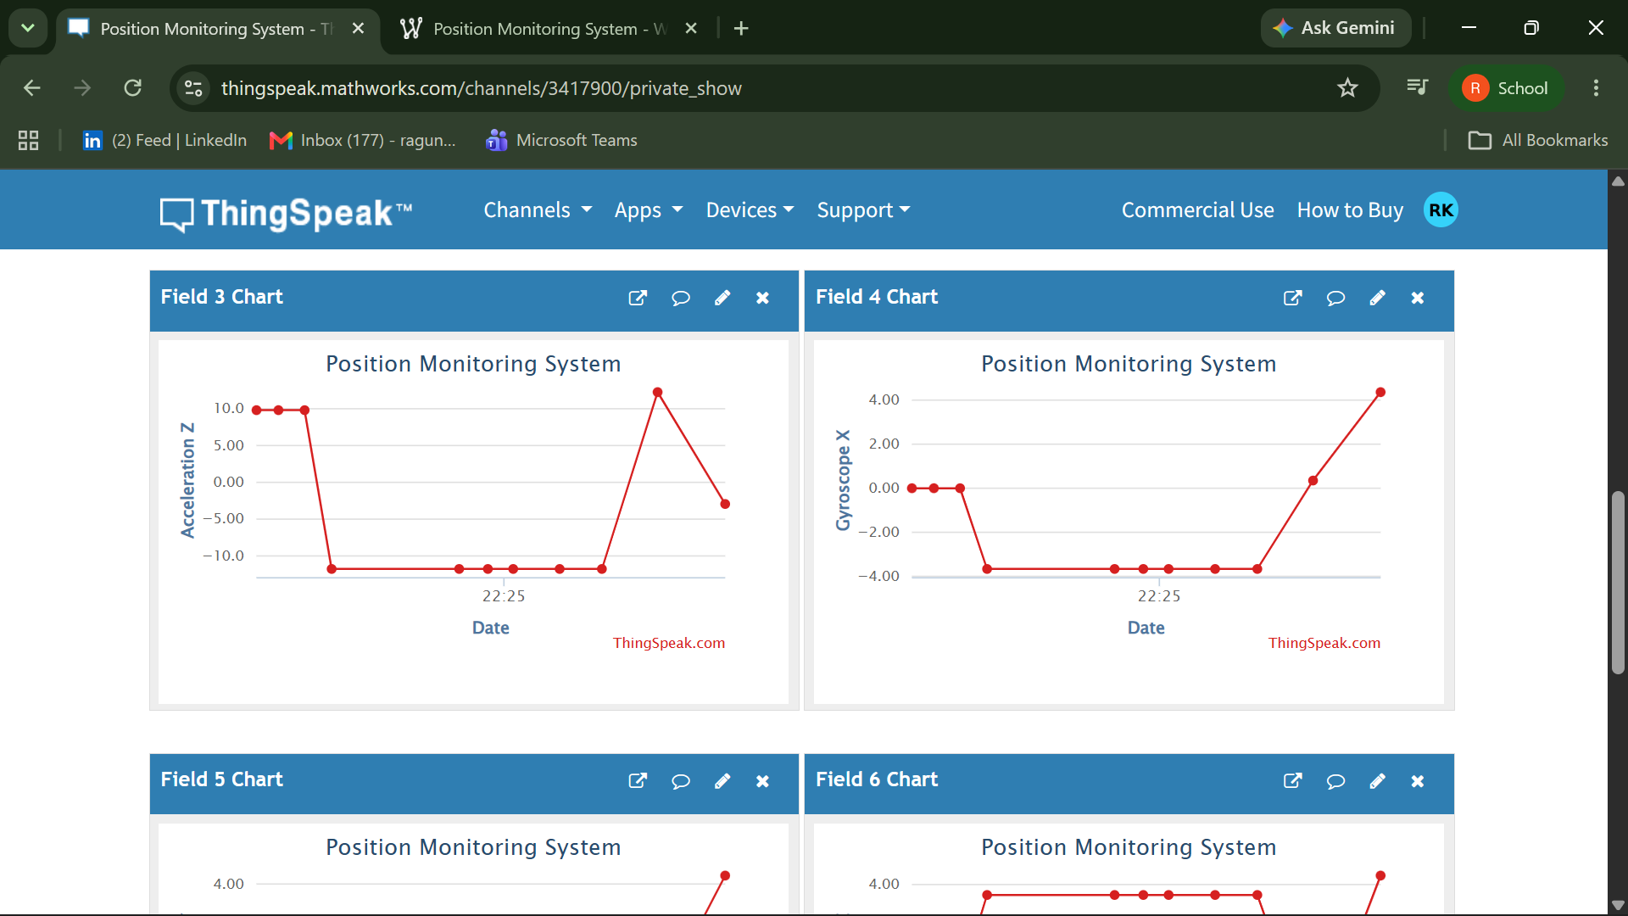

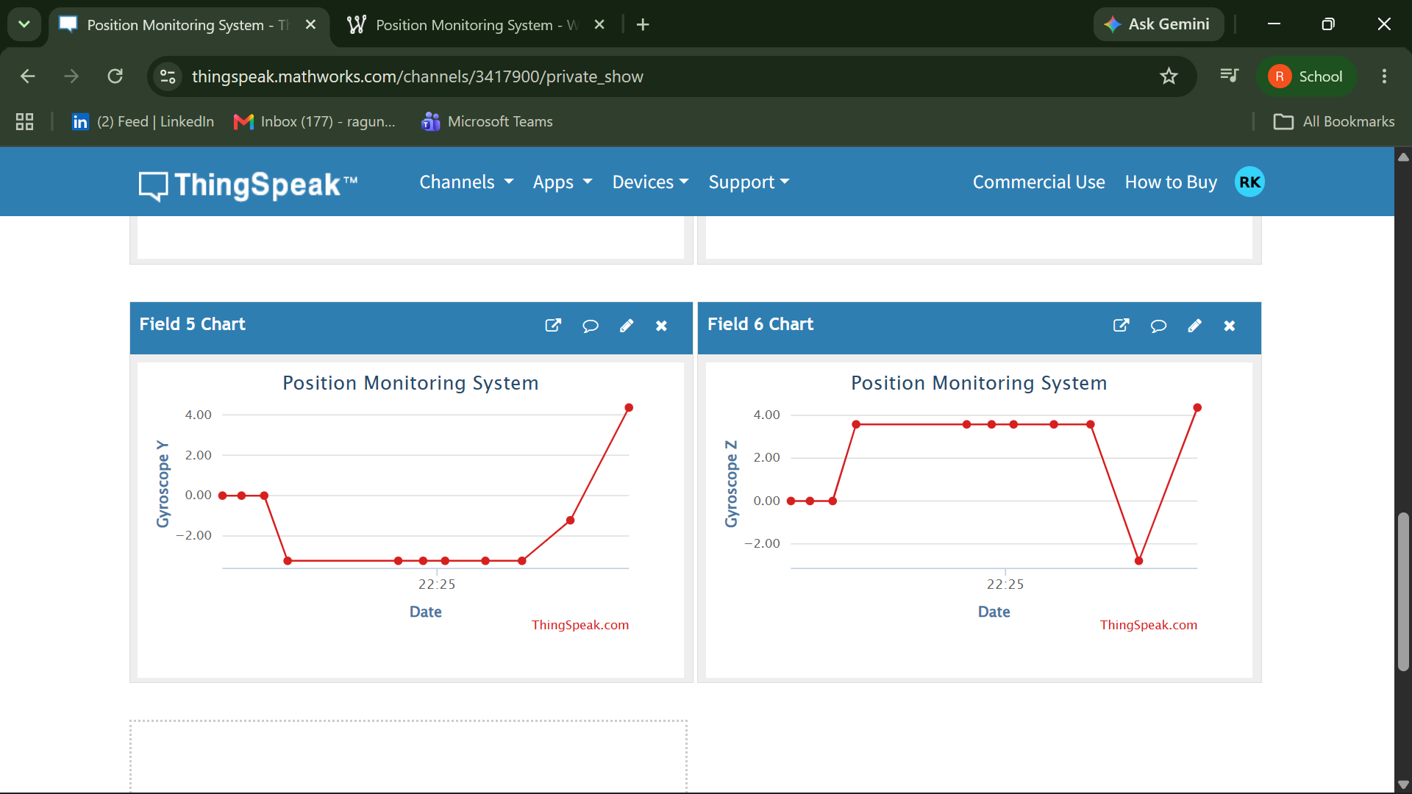

INFERENCE:
The developed IIoT-based Position Monitoring System successfully monitored the position and orientation of an object in real time. The integration of ESP32, MPU6050, OLED, Wokwi, and ThingSpeak demonstrated reliable data acquisition, processing, and cloud communication. The system enabled both local visualization on the OLED and remote monitoring through ThingSpeak graphs. The simulation verified the correctness of the hardware and software implementation before physical deployment. The project provides a scalable foundation for future Industrial IoT applications such as predictive maintenance and remote equipment monitoring.

RESULT:
The Position Monitoring System was successfully simulated using the Wokwi platform. The ESP32 accurately acquired acceleration and gyroscope data from the MPU6050 sensor

DEMO VIDEO LINK:
https://drive.google.com/file/d/1wB1urGcJ6d7Z0Mf3r8CuEKVQfI1505H2/view?usp=sharing/

